LAB # 11
INTRODUCTION TO TEST SUITE
OBJECT:
Grouping the multiple JUnit test cases and constructing a Test Suite program.
LAB TASK:
- Make a class having four functions for determining,
• Whether the input integer is odd.
• Whether the input integer is even.
• Whether the input integer is prime.
• For calculating the factorial of that input integer.

Write their test cases and execute them in a single test suite class. Follow all the steps mentioned above in the manual.

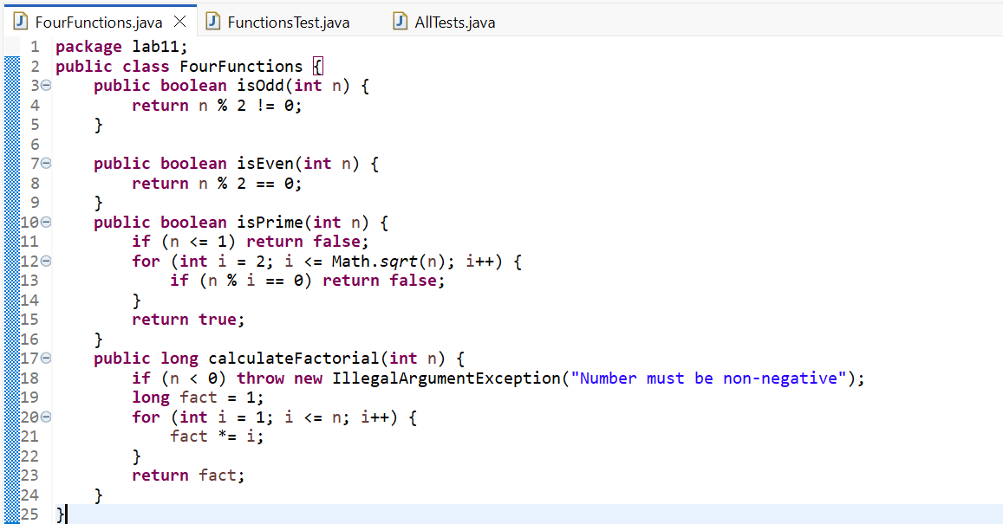
CODE:
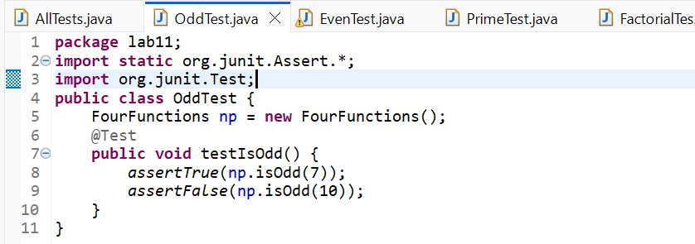
ODD TEST:

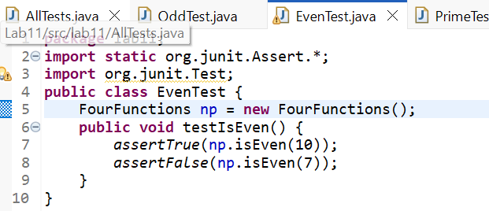
EVEN TEST:
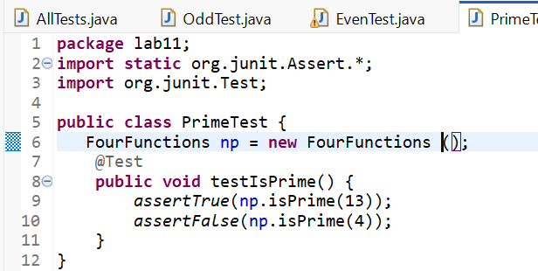
PRIME TEST:

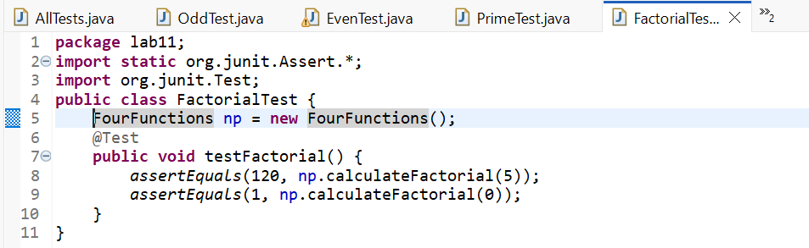
FACTORIAL TEST:

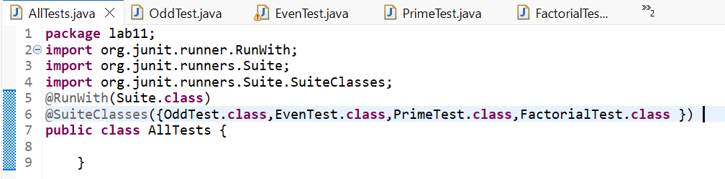
TEST SUITE:
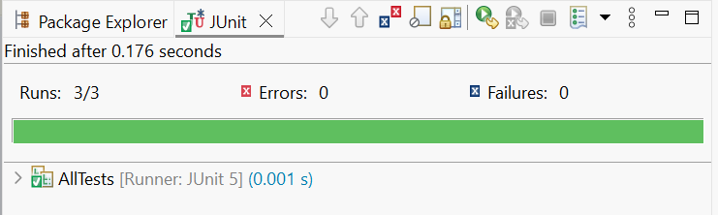
OUTPUT:
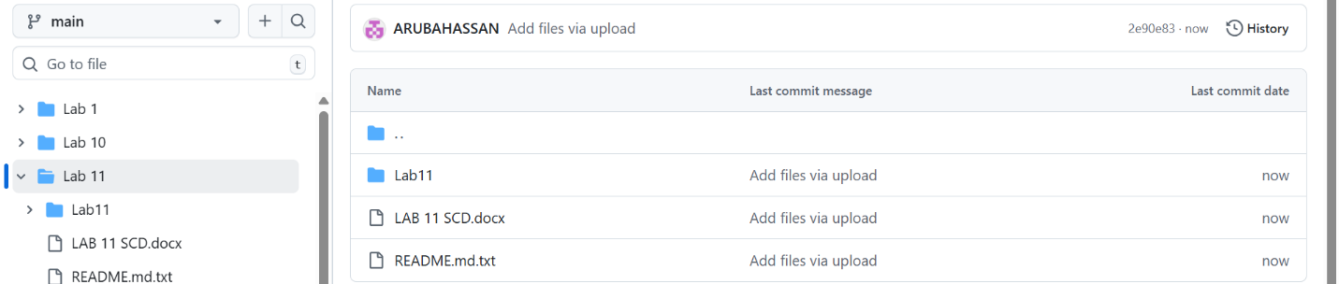
GITHUB UPLOADED SCREEN SHOT:

